RAINOW PRIMARY SCHOOL


Headteacher: Round Meadow
Mr J D NORRIS Rainow
Macclesfield
Telephone: Cheshire
01625 572021 SK10 5UB

Caring, Learning, Achieving.

E-Mail Address admin@rainowpri.cheshire.sch.uk
Website www.rainowpri.cheshire.sch.uk

30 July 2026
Parent Governor Vacancy

Dear Parents / Carers

The governing board is responsible for both the conduct of the school and for promoting high standards. The governing board carries out its role by setting the vision for the school and then ensuring that the school works efficiently and effectively towards achieving its vision. It does this by building a thorough knowledge of the school and its community, by both supporting and constructively challenging the school, and by ensuring accountability and compliance. The governing board of our school is made up of parent governors, staff governors, co-opted governors and a local authority governor.

A vacancy has arisen for a parent governor on our governing board. The governing board is asking you to nominate someone with parental responsibility for a child at the school. If more than two nominations are received, then a ballot will be held.

Before you decide to nominate someone, or indeed stand yourself, you may want to know a bit more about what is involved. Governors do not need to be experts in the field of education.

What they do need is an interest in the school and in the welfare of our children and the time and willingness to get involved. The skills you have can be very useful to the governing body. At the moment the governing board is lacking governors who have knowledge and experience with respect to the management of buildings, finance and who hold leadership positions in other organisations.

Governors also need what is known as ‘soft skills’ – the ability to be able to build relationships with a range of people, to be able to work as part of a team, to be able to question, and to make connections between different types of information. All governors are expected to be able to read straightforward budget reports and data on school standards.

Our governing body expects governors to:
  - attend three termly meetings of the full governing body. (approx. 2-3 hours per meeting, plus time to read associated papers);
  - sit on at least one committee and attend the meetings which are usually one per term (approx. 2-3 hours per meeting, plus extra time to read associated papers);
  - visit the school formally for monitoring purposes at least once per year;
  - commit to attend training courses, perform additional research as required and take part in monitoring at least one area within the school.

In return, our governing body commits to:
  - provide you with a structured induction;
  - provide access to quality training;
  - provide you with an experienced governor as mentor.

If you would like to find out more about how you can contribute to governance at our school, please email me with your contact details and I will pass on your details to the chair who will then arrange a time for a conversation. You might also like to look at the information for prospective governors on our website here, and the Department for Education website here:

Please note that for the protection of children all governor appointments are subject to a vetting process and identity check.

If you would like to put yourself forward as a candidate, please complete and return the nomination form and personal statement found at the end of this letter, along with the attached School Governor Eligibility Declaration Form, to the school office by Monday 4th March (midday). Your nomination should be accompanied by a short personal statement which should include:

  - evidence of the extent to which you possess the skills and experience the governing body desires;
  - your commitment to undertake training to acquire or develop the skills to be an effective governor;
  - if seeking re-election, details of your contribution to the work of the governing body during their previous term of office; and
  - how you plan to contribute to the future work of the governing body.

If it is necessary for there to be an election (more than 1 nominee), I will contact you to let you know about the voting arrangements.

Yours sincerely
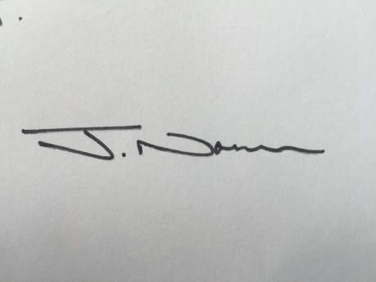
Jonathan Norris
Head teacher

P Riordan
Paula Riordan
Chair of Governors

Attached: School Governor Eligibility Declaration Form

Rainow School Election of Parent Governors…Eligibility Form…Personal Statement

Name:…………………………………………………………………………………………………………………………………………………………………

Address:……………………………………………………………………………………………………………………………………………………………..

…………………………………………………………………………………………………………………………………………………………………………...

……………………………………………………………………………………………………………………………………………………………………………

The above-named has a child at the school, is willing to serve if elected and is hereby nominated to stand for election.

Nominated by*: (name in capitals and address)…………………………………………………………………………………………………...............................................................

…………………………………………………………………………………………………………………………………………………………………………...

……………………………………………………………………………………………………………………………………………………………………………

Signature of nominee:…………………………………………………………………………………………………………………………………………

N.B. Completed nominations must be returned to the school by Monday 5th March (midday)

*Self-nomination is acceptable

Personal statement

The nominee should use the next page to complete their personal statement. The statement should be of sufficient length to set out:

• evidence of the extent to which you possess the skills and experience the governing body desires;
• your commitment to undertake training to acquire or develop the skills to be an effective governor;
• if seeking re-election, details of your contribution to the work of the governing body during your previous term of office; and
• how you plan to contribute to the future work of the governing body.

Personal Statement

Name of Nominee:……………………………………………………………..

